Assignment 5
N1
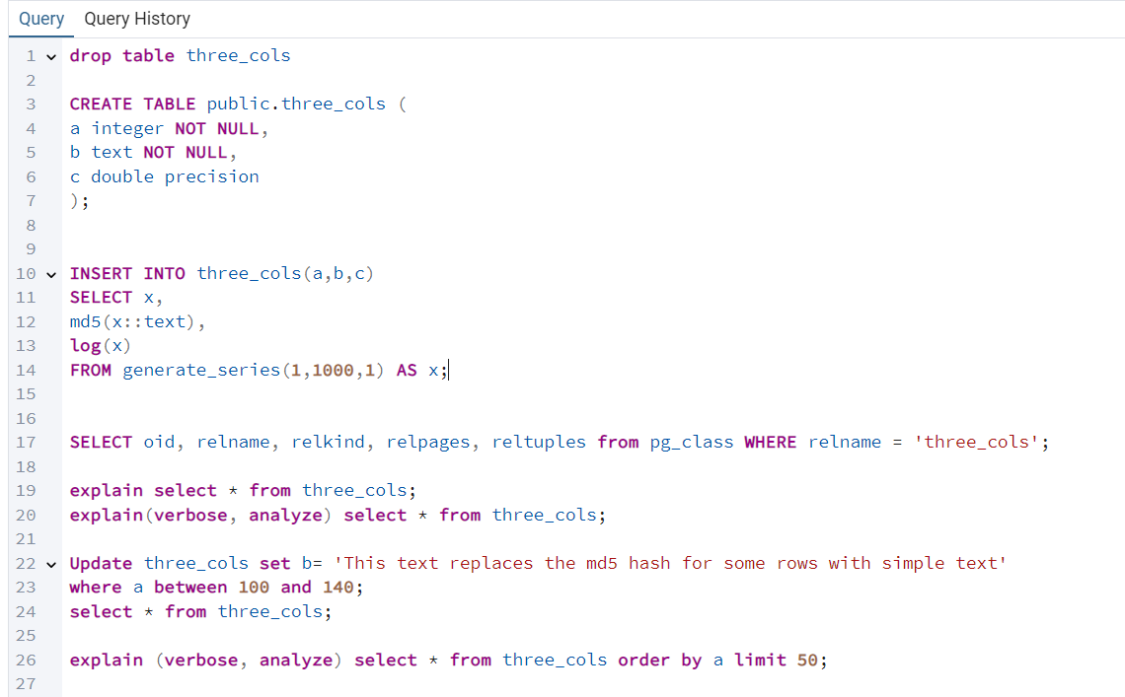
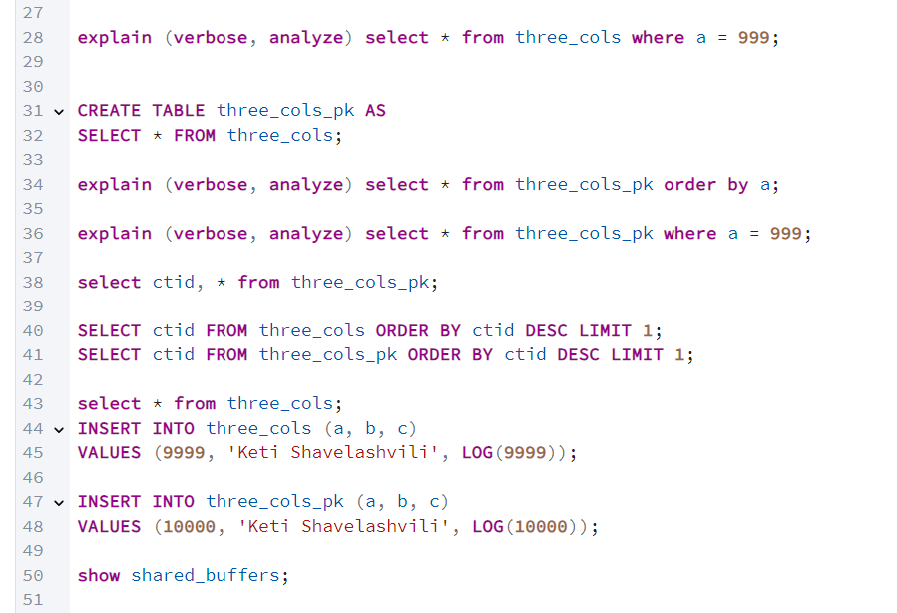
N2
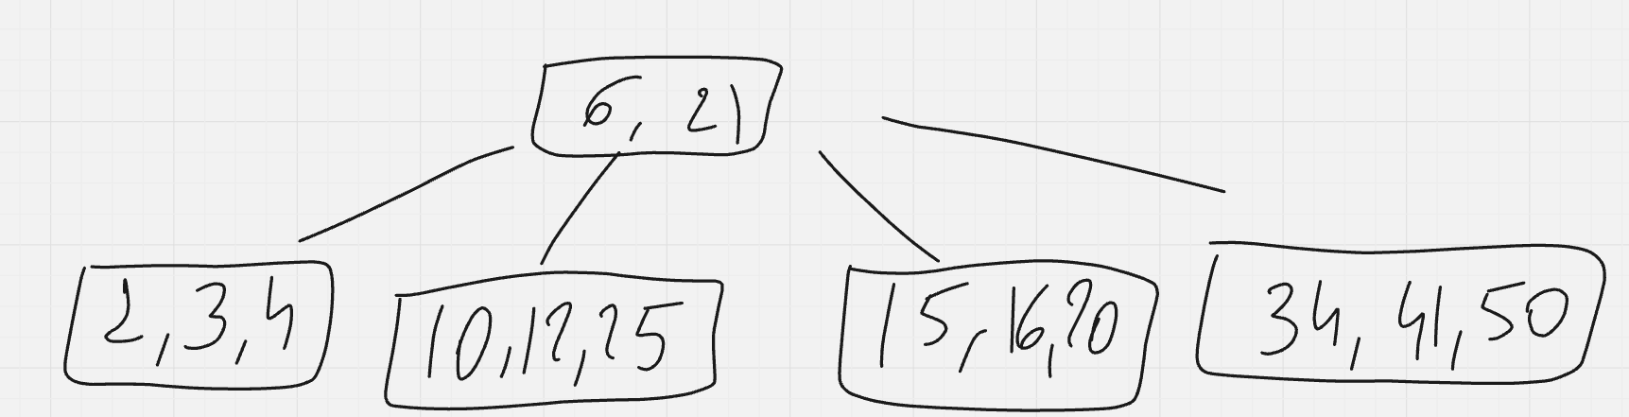
N3
The query is performing an inner join between the enrollment table and the student table, where the student ID in both tables matches. It then counts how many rows (courses) are associated with each student, grouping the result by student ID.

N4
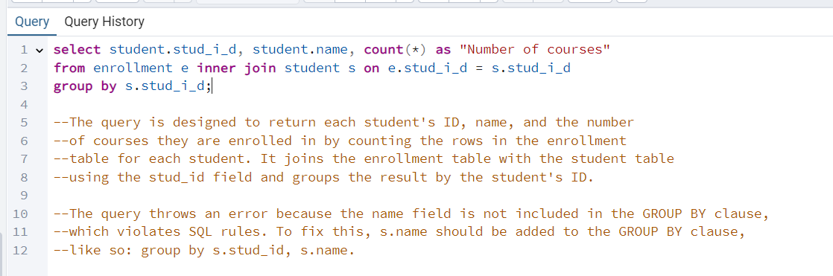

N5
